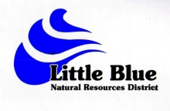
Little Blue Natural Resources District
Annual Water Quality Management Report

Operator Name:

Address:

City: Zip:

Cropping Information from 2022 Crop Year

Legal Description: __________________________________________
Total Irrigated Acres: ____________________
Crop(s) Planted in 2022_____________________
Crop(s) you plan on planting on this field in 2023__________________________

A Soil Sample is required if applying nitrogen to this field with a copy of the results
sent to the LBNRD office with this report.

This report is due by April 1, 2023.

I certify that the above information is accurate and correct to the best of my knowledge.

_________________________________________________ ___________________________
Signature Date

